Q-Learning Exercise:

- Open and run QLearning.IPYNB. The notebook has a train() method that learns a Q-table and a test() method that prints the optimal paths from each junction to the goal (S5). Compare outputs with the lecture diagram to sanity-check sequences.
- Change the goal to the maze centre: update the GOAL variable and adjust the Rewards Table R so actions that reach the new goal have high reward. Re-run train() and test() to verify new paths.

New scenario: rooms and outside: Model six states (rooms 0–4 and outside 5). Draw a directed graph with two-way arrows for every door between connected rooms, plus a self-loop on state 5 (absorbing goal).

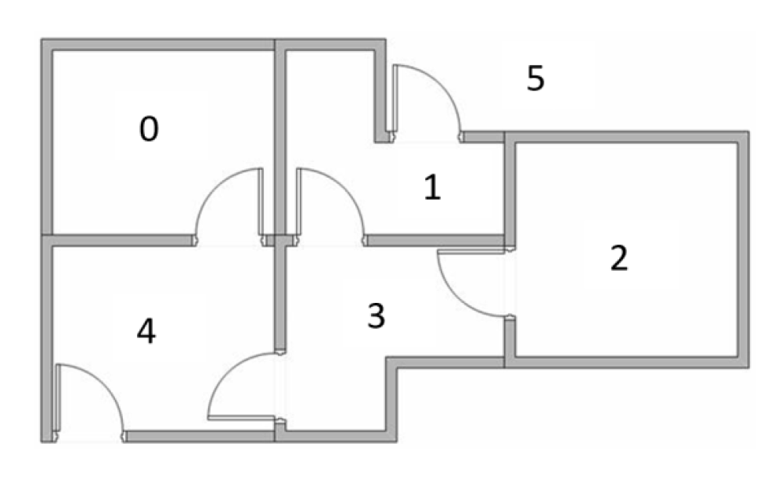

- Assign rewards: For any action that moves directly into state 5 (outside), set reward = 100. All other valid moves get 0. Invalid moves (no door) are marked as −1 to block those actions.
- Build the Rewards Table (R): Create a 6×6 matrix (rows = current state, columns = next state) filled with −1/0/100 per the graph in steps 3–4.
- Edit the notebook for the new task: Update INITIAL_STATES, (optionally) GOAL = 5, and replace R with your new 6×6 table. Do not change the learning logic.
- Train to compute the Q-table, then Test to extract the greedy policy (best action per state) and list the path(s) from any starting room to 5.

END.

